The Eisenhower Decision Matrix, is a time management and prioritisation tool that helps you decide what tasks to focus on by categorising them based on urgency and importance.
The four sections:
Do: Urgent and Important:
These are tasks that require immediate attention.
Decide: Important, but not Urgent:
These are tasks that contribute to your goals and values but don't have immediate deadlines.
Delegate: Urgent, but not Important:
These tasks demand immediate attention but aren’t necessarily urgent. These tasks could be delegated to someone else.
Delete: Neither Urgent nor Important:
These tasks are distractions and don't contribute to your goals, delete them.

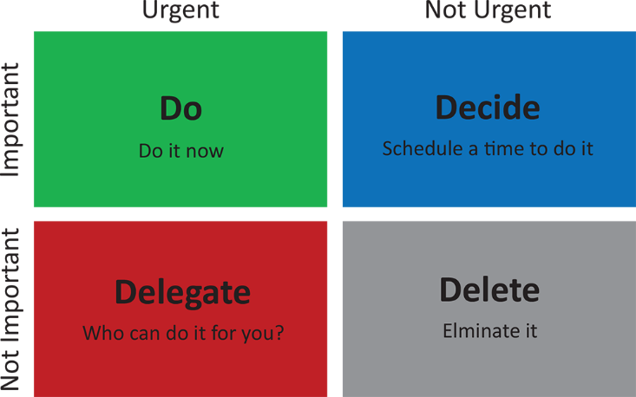

How to use:
List: Begin by creating a do to list of all your tasks and projects.
Categorise: Place each task into the appropriate section based on its urgency and importance.
Prioritise: Is it a green, blue, red or grey? Focus on tasks in the "Do" section first, then schedule time for the "Decide" section. Who would be best for this task? "Delegate" section and eliminate tasks in the "Delete" section.
By using the Eisenhower Matrix, you can better manage your time, reduce stress, and focus on the activities that truly matter.

To Do List:

Do:

Delegate:
Decide:
Delete:
Weekly Reflection Questions:
- What were my top 3 accomplishments this week?
(Celebrate wins and build momentum.)
- What tasks or goals didn’t get completed? Why?
(Identify patterns or blockers.)
- What took up the most time—and was it worth it?
(Assess how aligned your actions were to your priorities.)
- What could I have delegated or said no to?
(Spot opportunities for more effective time use.)
- Did I spend enough time on important, non-urgent work?
(Encourage strategic thinking, not just firefighting.)
- How did I manage distractions or interruptions?
(Build awareness of focus habits.)
- What will I do differently next week?

